## Higher order Componenet in React js by using class component

We are having 3 files :

* HIGHERORDERCOMPONENT
* BJP
* AAP

IN HIGHERORDERCOMPONENT WE DEFINE A FUNCTION THAT WILL BE USE IN BJP AND AAP BOTH…

DEFINITION: A higher-order component is a function that takes a component and returns a new component. A higher-order component (HOC) is the advanced technique in React.js for reusing a component logic. Higher-Order Components are not part of the React API. They are the pattern that emerges from React’s compositional nature. The component transforms props into UI, and a higher-order component converts a component into another component.

HIGHER ORDER COMPONENT

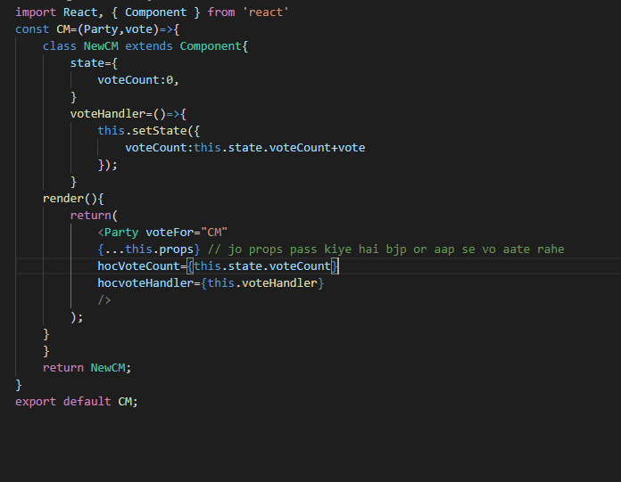

{…this.props} isliye pass kiya hai ki jo props pass kiya hai kejriwal or manoj tiwari ka.. vo aa jaye nhi likha to nhi ayega

BJP

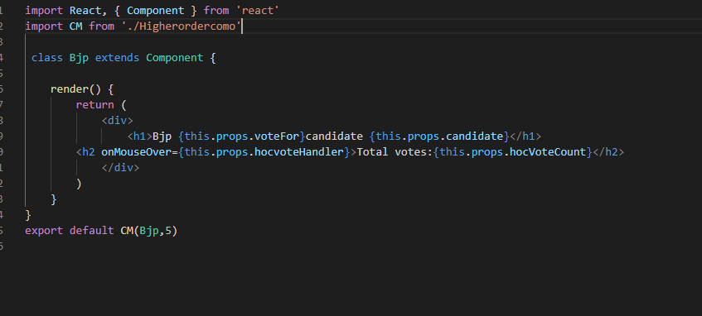

AAP

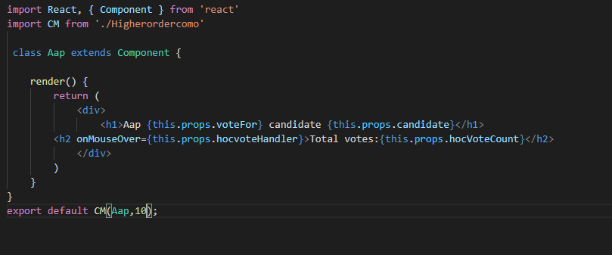

APP.JS FILE

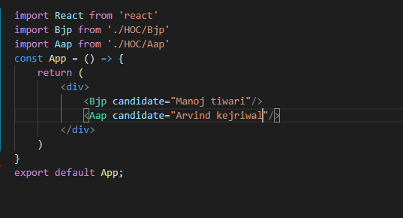

Output

